

**Carrier Xpower Gold 42CVSR018 703 1.5 Ton**

**Rs. 95,700/-**

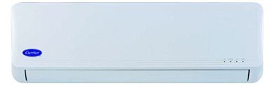

**Product Features**

* Independent Dehumidification
* Low Noise Air Flow System
* Easy Clean Panel
* Remote Control Pocket
* Three Minutes Protection

**Specification**

**Type** Wall Mounted Split AC

**Cooling (Btu/h)** 42000

**Voltage (V)** 220-240

**Power Input (W)** 3900

**EER (Btu/W-h-W/W)** 7.2-4.5